Subject: TOEIC 1
Lesson plan: 1 Time allowed: 6 periods Total period taught: 0
Date of teaching: 12/10/2015

UNIT 1: PRESENT TENSE

I. OBJECTIVES
By the end of the lesson, the students will be able to:
- Develop skills:
+ Listening skill: students listen to statements and choose the best answers for describing the pictures, listen to the short conversations and talks to find out the specific information in order to answer the required questions.
+ Reading skill: students know how to read letter, email, memo, chart…as well as pick up the information so as to answer the questions and choose the best words for blanks.
- Learn and do the exercises about present tense, preposition “at”, and commonly confused words.
II. TIME
-45 minutes x 6 periods = 270 minutes.
III. METHOD
-Integrated, communicative oriented teaching approach.
IV. TECHNIQUES
-Pair work.
-Group work.
V. TEACHING AIDS
-Text book.
-Black board, chalk.
-Pictures for teaching vocabularies.
-Cassette player, amplifier, microphone.
-Hand-outs for sub-exercises
VI. PROCEDURE
A.Greetings.
B.Checking students’ attendance: 5 minutes
C.New lesson.
Lesson’s contents | Time | Teacher’s activities | Students’ activities
VOCABULARY  A. LISTENING:  Listen and write the letter of the statement that best describes the picture.  B. READING:  Choose the correct words to complete each sentence | 20’  20’ | -Teacher (T) teaches new words.  Nod (v): using mime      Frawn (v): using picture  - T gives instruction.  - T asks Ss to try to describe the pictures.  - T plays the tape without pause.  - T checks the answers and asks Ss a question as follow: “What did you hear from the tape?”  - T gives the correct answers.  - T helps Ss distinguish commonly confused words: “though/through; already/yet; sometime/sometimes” by giving definition, examples and signals.  - T has Ss do the exercises.  - T asks Ss to translate each  sentence into Vietnamese.  - T corrects the answers. | -Ss write down new words.  -Ss listen to the T.  - Ss listen to the tape and answer the questions.  - Ss answer the T’s questions.  Exercise 1:  1. D 2. A 3. B 4. C  Exercise 2:  1. D 2. C  3. B 4. A  -Ss listen to the T and take note.  -Ss do the activity.  - Ss translate and explain why they choose this answer  -Ss check the answers.  Exercise 1:  1. through 2. though  Exercise 2:  1. already 2. Yet  Exercise 3:  1. sometimes  2. sometime
GRAMMAR FOCUS  PRESENT TENSE  - Simple present  - Present perfect  - Present progressive  - Present perfect progressive | 70’ | - T writes 4 sentences on the board.  1. The Earth is round.  2. I’m eating lunch right now.  3. We have lived here for 20 years.  4. He has been calling her all morning.  - T explains the grammar clearly.  - T asks Ss to give examples for each tense for checking understanding. | - Ss draw out grammar points such as structure, use and signal words.  - Ss listen to T.  - Ss give their own examples.
PREPOSITION: AT | 20’ | - T gives Ss 2 examples.  1. He works at night.  2. She lives at 123 Main Street.  - T reminds Ss some special cases using with preposition “At”: at home, at noon, at night, at school, etc. | - Ss draw out the use of preposition “At”.  - Ss write down in their notebook.
GRAMMAR  EXERCISES | 40’ | - T gives Ss time to do the exercise.  - T goes around the class to help Ss when they need.  - T calls on Ss to write their answer on the board.  - T gives feedbacks and corrects the answers. | - Ss do the exercise individually or in pairs.  - Ss write the answer on the board.  - Ss listen to T and correct their own answer.  Answers:  1. go  2. has studied  3. seen  4.have  5. been crying  6. plays  7. is running  8. studying  9. finished  10. laughing
MINI TEST  PART 1:  Picture Description  PART 2:  Questions and Responses  PART 3:  Short Conversations  PART 4:  Short Talks  PART 5:  Incomplete Sentences  PART 6:  Incomplete Texts  PART 7:  Reading Comprehension | 70’  60’  40’  50’ | - T gives Ss 10 minutes to look at 5 pictures in part 1.  - T asks Ss: “What can you see in the picture?”  “What are they?”  “What are they doing”  - T introduces some new words if necessary.  - T suggests some relating words.  - T gives instruction.  - T plays the tape.  - T checks the answers.  - T introduces instruction.  - T gives Ss two steps to do part 2:  + Step 1: Listen carefully to the question.  + Step 2: Listen 4 answers and choose the suitable answer for the question which Ss listened to.  - T plays the tape.  - T corrects the answers.  - T asks Ss to read the questions.  - T asks Ss to underline the key words in the question.  - T asks Ss: “To do part 3, what information do you need to listen out for?  - T plays the tape without pause.  - T asks Ss to write answer on the board.  - T plays the tape with pause and gives the correct answers.  - T asks Ss to read the questions.  - T asks Ss to underline the important words in the question.  - T asks Ss: “To do part 4, which information do you need to listen out for?  - T introduces some new words if necessary.  - T plays the tape without pause.  - T asks Ss to write answer on the board.  - T plays the tape with pause and gives the correct answers.  - T teaches some new words.  Comedy (n): using examples.  Clap (v): using mime  - T asks Ss to do part 5 in pairs  - T goes around the class if they need for help.  - T calls on some Ss to write their answers on the board.  - T checks Ss’ understanding and corrects the answers.  - T asks Ss to do part 6 in pairs.  - T goes around the class if they need for help.  - T calls on some students to write their answers on the board.  - T checks Ss’ understanding and corrects the answers.  - T gives instructions how to do part 7.  - T asks Ss to read the questions and underline the key words.  - T asks Ss to use scanning and skimming skills to find the specific information in the article.  - T asks Ss to do part 7 in pairs  - T goes around the class if they need for help.  - T explains new words.  Advertise (v): using explanation  Folk (n):using translation  Stomachache (n): using translation  Delicious (adj): using antonym  - T calls on some students to write their answers on the board.  - T asks Ss questions “How can you find out the answer? Which line/ paragraph can you find out the answer?  - T checks Ss’ understanding and corrects the answers. | - Ss look at pictures and answer T’s questions.  -Ss listen and choose the statements.  Answers:  1.B 2.A 3. A 4.C 5. D  - Ss listen and apply two steps to complete part 2.  -Ss check the answers.  Answers:  1. C 2. A 3. B 4. B 5. C  - Ss listen to the tape.  - Ss write down the answers on the board.  - Ss listen again and check their answers.  Answers:  1. D 2. C 3. C  4. B 5. D 6. B  - Ss read the questions in pairs.  - Ss underline the important words and answer T’s question.  -Ss do the exercise.  -Ss write down the answers on the board.  - Ss listen again and check their answers.  Answers:  1. A 2. B 3. A  4. C 5. D 6. D  - Ss read the questions in pairs.  -Ss explain the reason for their choices and write answers on the board.  -Ss check the answers.  Answers:  1. C 2. B 3. A  4. D 5. C 6. A  7. C 8. B 9. D  10. A 11. C 12. B 13. B 14. D 15. C  - Ss do part 6 in pairs.  - Ss write answers on the board.  - Ss explain the reason for their choice and correct the answers.  Answers:  1. C 2. A 3. C  4. C 5. B 6. B  - Ss do part 7 in pairs.  -Ss follow T’s instruction.  -Ss take note new words.  - Ss write answers on the board.  - Ss explain the reason for their choice and correct the answers.  Answers:  1. A 2. D 3. B  4. D 5. C
STUDENTS TEACH THEMSELVES AT HOME |  | -T asks Ss to do this part at home.  Reading Comprehension: Questions 6 through 9  [Page 28] | -Ss should practive on their own at home.  - Ss look up the new words in the dictionary.  - Ss answer the questions by themselves.  - Ss themselves explain why they chose the answers from the clues in the text.

VII. SUMMARY OF UNIT 1: 5 minutes
- T reminds Ss about:
+ Present Tense
+ Vocabulary and Grammar Exercises
+ Six parts of the Mini Test.
VIII. HOMEWORK: 5 minutes
- Ss have to do again all the exercises.
- Ss prepare for the new lesson.
IX. SELF-ASSESSMENT:
- The teaching methods are good because:
+ There are facilities and materials for students to study better.
+ The teacher’s preparation is careful.

October 2nd, 2013
ADOPTION OF ENGLISH GROUP Teacher’s signature

Phạm Thị Thu Hiền

Subject: TOEIC 1
Lesson plan: 2 Time allowed: 6 periods Total period taught: 6
Date of teaching: 26/10/2015

UNIT 2: PAST TENSE

I. OBJECTIVES
By the end of the lesson, the students will be able to:
- Develop skills:
+ Listening skill: students listen to statements and choose the best answers for describing the pictures, listen to the short conversations and talks to find out the specific information in order to answer the required questions.
+ Reading skill: students know how to read letter, email, memo, chart…as well as pick up the information so as to answer the questions and choose the best words for blanks.
- Learn and do the exercises about past tense, preposition “in”, and commonly confused words.
II. TIME
-45 minutes x 6 periods = 270 minutes.
III. METHOD
-Integrated, communicative oriented teaching approach.
IV. TECHNIQUES
-Pair work.
-Group work.
V. TEACHING AIDS
-Text book.
-Black board, chalk.
-Pictures for teaching vocabularies.
-Cassette player, amplifier, microphone.
-Hand-outs for sub-exercises
VI. PROCEDURE
A.Greetings.
B.Checking students’ attendance: 5 minutes
C.Checking the old lesson: Present Perfect Simple vs Present Perfect progressive
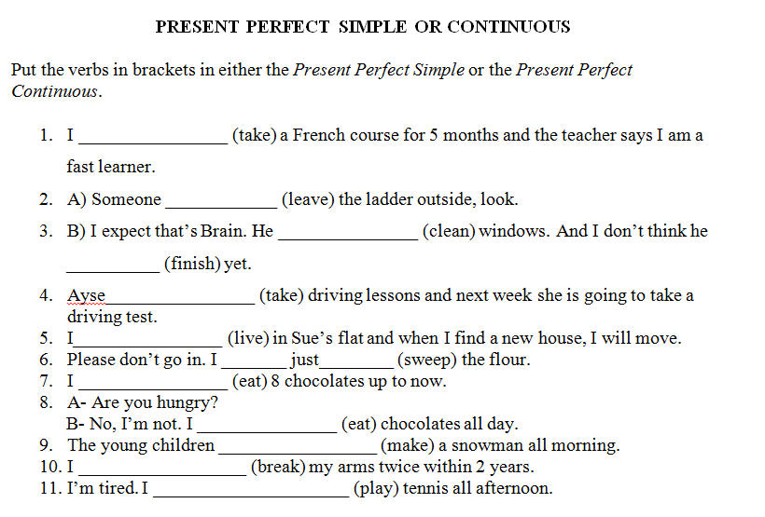

D.New lesson.
Lesson’s contents | Time | Teacher’s activities | Students’ activities
VOCABULARY  A. LISTENING:  Listen and write the letter of the statement that best describes the picture.  B. READING:  Choose the correct words to complete each sentence | 20’  20’ | -Teacher (T) teaches new words.  Try on (v): using examples  Lend (v) # Borrow (v): using antonym    Shake (v):using picture  - T gives instruction.  - T plays the tape without pause.  - T checks the answers and asks Ss a question as follow: “What did you hear from the tape?”  - T gives the correct answers.  - T helps Ss distinguish commonly confused words by giving definition, examples and signals.  Borrow (v): to take and use something that belongs to someone else, and return it later.  Lend (v) # Borrow (v)  Appointment (n): a formal arrangement to visit s/o at a particular time.  Promise (n): a statement that you tell somebody that you definitely do/do not do  Used to + V infinitive: talk about thing that happened in the past.  Be/get used to + V-in: become accustomed to it  - T has Ss do the exercises.  - T asks Ss to translate each  sentence into Vietnamese.  - T corrects the answers. | -Ss write down new words.  -Ss listen to the T.  - Ss listen to the tape and answer the questions.  - Ss answer the T’s questions.  Exercise 1:  1. B 2. D 3. C 4. A  Exercise 2:  1. A 2. C  3. D 4. B  -Ss listen to the T and take note.  -Ss do the activity.  - Ss translate and explain why they choose this answer  -Ss check the answers.  Exercise 1:  1. borrowed  2. lend  Exercise 2:  1. an appointment  2. a promise  Exercise 3:  1. be used to  2. used to
GRAMMAR FOCUS  PRESENT TENSE  - Simple past  - Past perfect  - Past progressive  - Past perfect progressive | 70’ | - T writes 4 sentences on the board.  1. We went shopping yesterday.  2. She had brought the book before I met her.  3. When Jackie got there, Steve was waiting for her.  4. He said he had been doing his homework since six o’clock.  - T explains the grammar clearly.  - T asks Ss to give examples for each tense for checking understanding. | - Ss draw out grammar points such as structure, use and signal words.  - Ss listen to T.  - Ss give their own examples.
PREPOSITION: IN | 20’ | - T gives Ss 2 examples.  1. I used to live in a house.  2. She went to Australia in 2002.  - T reminds Ss some special cases using with preposition “In”: in the evening, in spring, in a month, etc. | - Ss draw out the use of preposition “In”.  - Ss write down in their notebook.
GRAMMAR  EXERCISES | 40’ | - T gives Ss time to do the exercise.  - T goes around the class to help Ss when they need.  - T calls on Ss to write their answer on the board.  - T gives feedbacks and corrects the answers. | - Ss do the exercise individually or in pairs.  - Ss write the answer on the board.  - Ss listen to T and correct their own answer.  Answers:  1.was  2.sold  3.was taking  4.used to  5.finished  6.had been waiting  7.was reading  8.returned  9.borrowed  10.had been waiting
MINI TEST  PART 1:  Picture Description  PART 2:  Questions and Responses  PART 3:  Short Conversations  PART 4:  Short Talks  PART 5:  Incomplete Sentences  PART 6:  Incomplete Texts  PART 7:  Reading Comprehension | 70’  60’  40’  50’ | - T gives Ss 10 minutes to look at 5 pictures in part 1.  - T asks Ss: “What can you see in the picture?”  “What is he holding?”  “Where is that girl?”  “What are they doing”  - T introduces some new words if necessary.  Golf clubs (n): using picture    - T gives instruction.  - T plays the tape.  - T checks the answers.  - T introduces instruction.  - T gives Ss two steps to do part 2:  + Step 1: Listen carefully to the question.  + Step 2: Listen 4 answers and choose the suitable answer for the question which Ss listened to.  - T plays the tape.  - T corrects the answers.  - T asks Ss to read the questions.  - T asks Ss to underline the key words in the question.  - T asks Ss: “To do part 3, what information do you need to listen out for?  - T plays the tape without pause.  - T asks Ss to write answer on the board.  - T plays the tape with pause and gives the correct answers.  - T asks Ss to read the questions.  - T asks Ss to underline the important words in the question.  - T asks Ss: “To do part 4, which information do you need to listen out for?  - T introduces some new words if necessary.  Staff (n): using translation  Famous(adj): using semantic map      Prize (n): using pictures  - T plays the tape without pause.  - T asks Ss to write answer on the board.  - T plays the tape with pause and gives the correct answers.  - T asks Ss to do part 5 in pairs.  - T teaches some new words.  - T goes around the class if they need for help.  - T calls on some Ss to write their answers on the board.  - T checks Ss’ understanding and corrects the answers.  - T asks Ss to do part 6 in pairs.  - T teaches new words.  Patient (adj): using semantic map.  Offer (v): using translation  - T goes around the class if they need for help.  - T calls on some students to write their answers on the board.  - T checks Ss’ understanding and corrects the answers.  - T gives instructions how to do part 7.  - T asks Ss to read the questions and underline the key words.  - T asks Ss to use scanning and skimming skills to find the specific information in the article  - T asks Ss to do part 7 in pairs  - T goes around the class if they need for help.  - T explains new words.    Speaker(v): using picture  private (adj) using semantic map  tutor (n): using translation  - T calls on some students to write their answers on the board.  - T asks Ss questions “How can you find out the answer? Which line/ paragraph can you find out the answer?  - T checks Ss’ understanding and corrects the answers. | - Ss look at pictures and answer T’s questions.  -Ss listen and choose the statements.  Answers:  1.D 2.B 3. D 4.B 5. D  - Ss listen and apply two steps to complete part 2.  -Ss check the answers.  Answers:  1. C 2. A 3. B 4. B 5. C  - Ss listen to the tape.  - Ss write down the answers on the board.  - Ss listen again and check their answers.  Answers:  1. B 2. D 3. A  4. B 5. C 6. B  - Ss read the questions in pairs.  - Ss underline the important words and answer T’s question.  -Ss take note new words.  -Ss do the exercise.  -Ss write down the answers on the board.  - Ss listen again and check their answers.  Answers:  1. B 2. D 3. C  4. A 5. D 6. C  - Ss read the questions in pairs.  -Ss explain the reason for their choices and write answers on the board.  -Ss check the answers.  Answers:  1. A 2. D 3. B  4. C 5. D 6. C  7. B 8. D 9. B  10. A 11. D 12. C  13. D 14. A 15. D  - Ss do part 6 in pairs.  - Ss write answers on the board.  - Ss explain the reason for their choice and correct the answers.  Answers:  1. C 2. C 3. C  4. B 5. D 6. C  -Ss follow the instructions.  - Ss do part 7 in pairs.  -Ss take note new words.  - Ss write answers on the board.  - Ss explain the reason for their choice and correct the answers.  Answers:  1. B 2. A 3. B  4. C 5. A 6. B  7. A 8. D 9. B
STUDENTS TEACH THEMSELVES AT HOME |  | -T asks Ss to practice themselves at home.  Reading Comprehension:  - Questions 4 through 6  [ Page 39]  - Questions 6 through 9  [ Page 42] | - Ss look up the new words in the dictionary.  - Ss answer the questions by themselves.  - Ss themselves explain why they chose the answers from the clues in the text.

VII. SUMMARY OF UNIT 2: 5 minutes
- T reminds Ss about:
+ Past Tense
+ Vocabulary and Grammar Exercises
+ Six parts of the Mini Test.
VIII. HOMEWORK: 5 minutes
- Ss have to do again all the exercises.
- Ss prepare for the new lesson.
IX. SELF-ASSESSMENT:
- The teaching methods are good because:
+ There are facilities and materials for students to study better.
+ The teacher’s preparation is careful.

October 2nd, 2015
ADOPTION OF ENGLISH GROUP Teacher’s signature

Phạm Thị Thu Hiền

Subject: TOEIC 1
Lesson plan: 3 Time allowed: 6 periods Total period taught: 12
Date of teaching: 9/11/2015

UNIT 3: GERUND/INFINITIVES

I. OBJECTIVES
By the end of the lesson, the students will be able to:
- Develop skills:
+ Listening skill: students listen to statements and choose the best answers for describing the pictures, listen to the short conversations and talks to find out the specific information in order to answer the required questions.
+ Reading skill: students know how to read letter, email, memo, chart…as well as pick up the information so as to answer the questions and choose the best words for blanks.
- Learn and do the exercises about gerund/infinitives, preposition “from”, and commonly confused words.
II. TIME
-45 minutes x 6 periods = 270 minutes.
III. METHOD
-Integrated, communicative oriented teaching approach.
IV. TECHNIQUES
-Pair work.
-Group work.
V. TEACHING AIDS
-Text book.
-Black board, chalk.
-Pictures for teaching vocabularies.
-Cassette player, amplifier, microphone.
VI. PROCEDURE
A.Greetings.
B.Checking students’ attendance: 5 minutes
C.Checking the old lesson: Past Simple, Past Progressive vs Past Perfect, and Present Perfect.
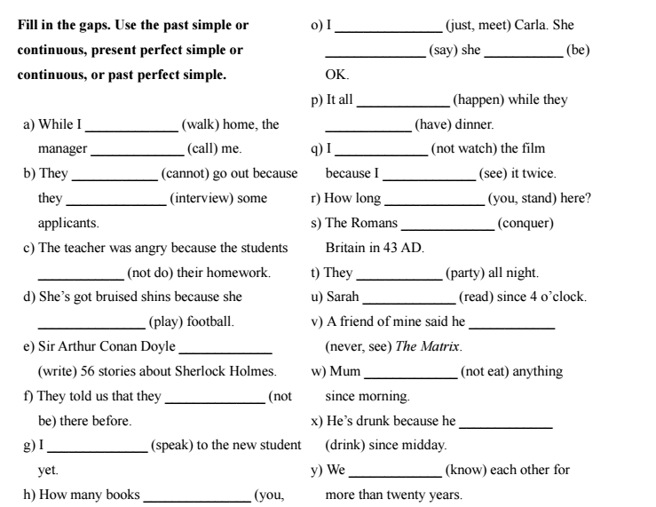

D.New lesson.
Lesson’s contents | Time | Teacher’s activities | Students’ activities
VOCABULARY  A. LISTENING:  Listen and write the letter of the statement that best describes the picture.  B. READING:  Choose the correct words to complete each sentence | 20’  20’ | -Teacher (T) teaches new words.    Stretch (v): using picture  Remind (v) using explanation    Row (v):using picture  - T gives instruction.  - T plays the tape without pause.  - T checks the answers and asks Ss a question as follow: “What did you hear from the tape?”  - T gives the correct answers.  - T helps Ss distinguish commonly confused words by giving definition, examples and signals.  Fun (adj): something enjoyable, exciting  Funny (adj): something that makes you laugh.  Mind(v): be annoyed, be worried about  Remind (v)= make someone think about something again  Get on (v) go onto the bus, train, etc  Take (v): go by bus  - T has Ss do the exercises.  - T asks Ss to translate each  sentence into Vietnamese.  - T corrects the answers. | -Ss write down new words.  -Ss listen to the T.  - Ss listen to the tape and answer the questions.  - Ss answer the T’s questions.  Exercise 1:  1. C 2. A 3. B 4. D  Exercise 2:  1. D 2. A  3. B 4. C  -Ss listen to the T and take note.  -Ss do the activity.  - Ss translate and explain why they choose this answer  -Ss check the answers.  Exercise 1:  1. fun  2. funny  Exercise 2:  1. mind  2. remind  Exercise 3:  1. takes  2. get on
GRAMMAR FOCUS  PRESENT TENSE  - Simple past  - Past perfect  - Past progressive  - Past perfect progressive | 70’ | - T writes some examples on the board.  1. I enjoy reading  2. I want to travel to Australia.  - T explains the grammar clearly.  TO+ INF:  +agree, decide, expect, hope, want, etc.  + After adjectives  +Express purpose/ reason  VERB + VERB-ING:  + avoid, deny, enjoy, give up, mind, etc.  + After preposition  +At the subject of the sentences.  - T asks Ss to give examples for each tense for checking understanding. | - Ss draw out grammar points such as structure, use and signal words.  - Ss listen to T.  - Ss give their own examples.
PREPOSITION: FROM | 20’ | - T gives Ss 2 examples.  1. We work from 9 a.m to 6 p.m.  2. I got a watch from my father.  - T reminds Ss some special cases using with preposition “In”: from the start, from Ireland, etc. | - Ss draw out the use of preposition “from”.  - Ss write down in their notebook.
GRAMMAR  EXERCISES | 40’ | - T gives Ss time to do the exercise.  - T goes around the class to help Ss when they need.  - T calls on Ss to write their answer on the board.  - T gives feedbacks and corrects the answers. | - Ss do the exercise individually or in pairs.  - Ss write the answer on the board.  - Ss listen to T and correct their own answer.  Answers:  1.going  2.to help  3.to travel  4.seeing  5.swimming  6.to buy  7.buying  8.to get  9.smoking  10.going
MINI TEST  PART 1:  Picture Description  PART 2:  Questions and Responses  PART 3:  Short Conversations  PART 4:  Short Talks  PART 5:  Incomplete Sentences  PART 6:  Incomplete Texts  PART 7:  Reading Comprehension | 70’  60’  40’  50’ | - T gives Ss 10 minutes to look at 5 pictures in part 1.  - T asks Ss: “What can you see in the picture?”  “Where are they?”  “What is she doing?”  “What are they doing”  - T introduces some new words if necessary.  Church (n): using picture      Kite (n): using picture    Painting (v): using picture  - T gives instruction.  - T plays the tape.  - T checks the answers.  - T asks Ss to repeat two steps to do part 2:  + Step 1: Listen carefully to the question.  + Step 2: Listen 4 answers and choose the suitable answer for the question which Ss listened to.  - T plays the tape.  - T corrects the answers.  - T asks Ss to read the questions.  - T asks Ss to underline the key words in the question.  - T asks Ss: “To do part 3, what information do you need to listen out for?  - T plays the tape without pause.  - T asks Ss to write answer on the board.  - T plays the tape with pause and gives the correct answers.  - T asks Ss to read the questions.  - T asks Ss to underline the important words in the question.  - T asks Ss: “To do part 4, which information do you need to listen out for?  - T introduces some new words if necessary.  Postpone (v): using translation  Venue (n): using translation  - T plays the tape without pause.  - T asks Ss to write answer on the board.  - T plays the tape with pause and gives the correct answers.  - T asks Ss to do part 5 in pairs.  - T teaches some new words.  Comb (v) : using mime  Tired of (adj): using explantion    Autograph (n): using picture  - T goes around the class if they need for help.  - T calls on some Ss to write their answers on the board.  - T checks Ss’ understanding and corrects the answers.  - T asks Ss to do part 6 in pairs.  - T teaches new words.  Speech (n): using translation  Pleasure (n): synonym  Complain (v): using translation  Suggest (v): using translation  - T goes around the class if they need for help.  - T calls on some students to write their answers on the board.  - T checks Ss’ understanding and corrects the answers.  - T asks Ss to do part 7 in pairs  - T goes around the class if they need for help.  - T explains new words.    Pick up (v): using mime  Army (n): using picture  Check up (v): using translation  dramatic (adj) using semantic map  - T calls on some students to write their answers on the board.  - T asks Ss questions “How can you find out the answer? Which line/ paragraph can you find out the answer?  - T checks Ss’ understanding and corrects the answers. | - Ss look at pictures and answer T’s questions.  -Ss take note new words.  -Ss listen and choose the statements.  Answers:  1.A 2.A 3.B 4. A 5. C  -Ss respond to the T.  - Ss listen and apply two steps to complete part 2.  -Ss check the answers.  Answers:  1. B 2. B 3. B 4. A 5. B  - Ss listen to the tape.  - Ss write down the answers on the board.  - Ss listen again and check their answers.  Answers:  1. C 2. D 3. B  4. B 5. B 6. C  - Ss read the questions in pairs.  - Ss underline the important words and answer T’s question.  -Ss take note new words.  -Ss do the exercise.  -Ss write down the answers on the board.  - Ss listen again and check their answers.  Answers:  1. C 2. A 3. D  4. D 5. D 6. A  - Ss read the questions in pairs.  -Ss take note.  -Ss explain the reason for their choices and write answers on the board.  -Ss check the answers.  Answers:  1. B 2. D 3. B  4. C 5. A 6. B  7. D 8. C 9. C  10. B 11. D 12. B  13. D 14. C 15. C  - Ss do part 6 in pairs.  - Ss write answers on the board.  - Ss explain the reason for their choice and correct the answers.  Answers:  1. C 2. D 3. B  4. C 5. A 6. D  - Ss do part 7 in pairs.  -Ss take note new words.  - Ss write answers on the board.  - Ss explain the reason for their choice and correct the answers.  Answers:  1. B 2.D 3. C  4. D 5. C 6. A  7. B 8. D 9. B
STUDENTS TEACH THEMSELVES AT HOME |  | -T asks Ss to practice themselves at home.  Reading Comprehension:  - Questions 6 through 9  [ Page 56] | - Ss look up the new words in the dictionary.  - Ss answer the questions by themselves.  - Ss themselves explain why they chose the answers from the clues in the text.

VII. SUMMARY OF UNIT 3: 5 minutes
- T reminds Ss about:
+ Gerund/ Infinitives
+ Vocabulary and Grammar Exercises
+ Six parts of the Mini Test.

VIII. HOMEWORK: 5 minutes
- Ss have to do again all the exercises.
- Ss prepare for the new lesson.
IX. HANDOUTS

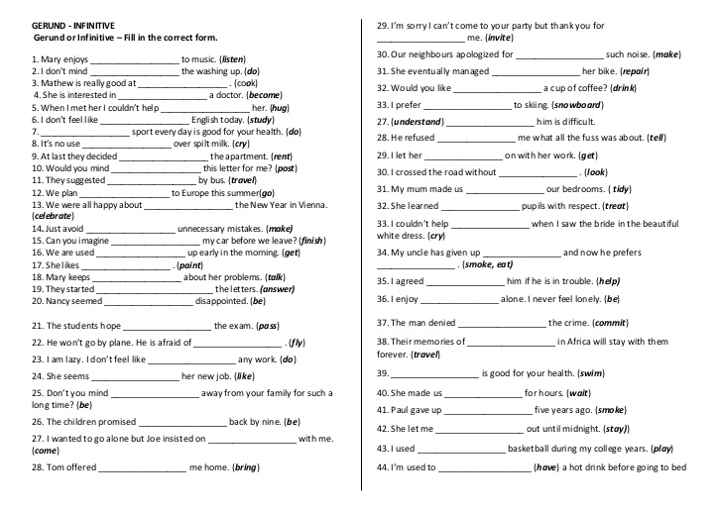

X. SELF-ASSESSMENT:
- The teaching methods are good because:
+ There are facilities and materials for students to study better.
+ The teacher’s preparation is careful.

October 2nd, 2015
ADOPTION OF ENGLISH GROUP Teacher’s signature

Phạm Thị Thu Hiền

Subject: TOEIC 1
Lesson plan: 4 Time allowed: 6 periods Total period taught: 20
Date of teaching: 23/11/2015

UNIT 4: NOUNS/ PRONOUNS

I. OBJECTIVES
By the end of the lesson, the students will be able to:
- Develop skills:
+ Listening skill: students listen to statements and choose the best answers for describing the pictures, listen to the short conversations and talks to find out the specific information in order to answer the required questions.
+ Reading skill: students know how to read letter, email, memo, chart…as well as pick up the information so as to answer the questions and choose the best words for blanks.
- Learn and do the exercises about nouns/pronouns, preposition “for”, and commonly confused words.
II. TIME
-45 minutes x 6 periods = 270 minutes.
III. METHOD
-Integrated, communicative oriented teaching approach.
IV. TECHNIQUES
-Pair work.
-Group work.
V. TEACHING AIDS
-Text book.
-Black board, chalk.
-Pictures for teaching vocabularies.
-Cassette player, amplifier, microphone.
VI. PROCEDURE
A.Greetings.
B.Checking students’ attendance: 5 minutes
C.Checking the old lesson: Gerund/ Infinitive

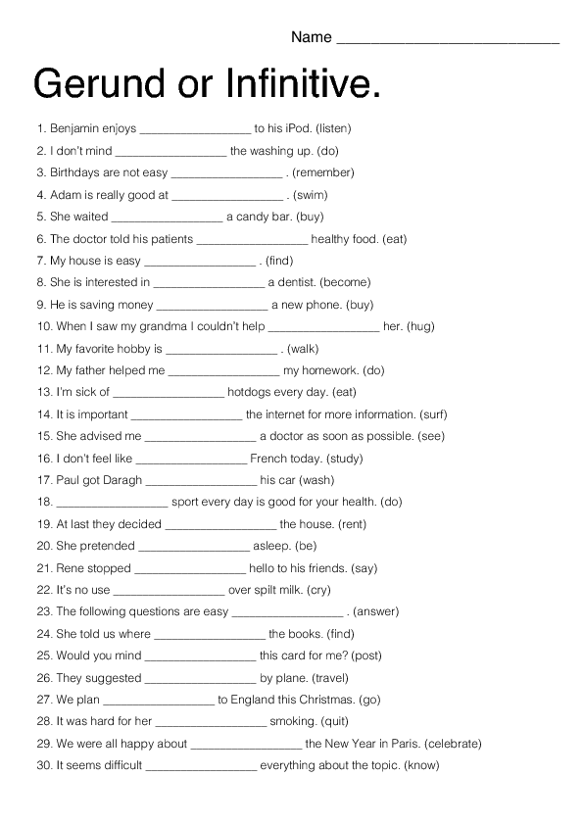

D.New lesson.
Lesson’s contents | Time | Teacher’s activities | Students’ activities
VOCABULARY  A. LISTENING:  Listen and write the letter of the statement that best describes the picture.  B. READING:  Choose the correct words to complete each sentence | 20’  20’ | -Teacher (T) teaches new words.  Chew (v): using mime  Feed(v) using explanation  Pour(v):using mime  - T gives instruction.  - T asks Ss to describe what they see in the pictures.  - T plays the tape without pause.  - T checks the answers and asks Ss a question as follow: “What did you hear from the tape?”  - T gives the correct answers.  - T helps Ss distinguish commonly confused words by giving definition, examples and signals.    Desert (n): using picture  Dessert (n): using picture    A little: using an uncountable noun  A few: using a plural countable noun  Any: using in negative sentences and questions.  Some: +using with both countable and uncountable nouns.  + in positive sentences, offering, requests.  - T has Ss do the exercises.  - T asks Ss to translate each  sentence into Vietnamese.  - T corrects the answers. | -Ss write down new words.  -Ss listen to the T.  - Ss listen to the tape and answer the questions.  - Ss answer the T’s questions.  Exercise 1:  1. D 2. A 3. B 4. A Exercise 2:  1. B 2. A  3. D 4. C  -Ss listen to the T and take note.  -Ss do the activity.  - Ss translate and explain why they choose this answer  -Ss check the answers.  Exercise 1:  1. desert  2. dessert  Exercise 2:  1. a little  2. a few  Exercise 3:  1. some  2. any
GRAMMAR FOCUS  Nouns and Pronouns  -Countable Nouns  -Uncountable Nouns  -Nouns can act as subjects, complements, and objects.  -Personal Nouns  -Indefinite Pronouns | 70’ | - T writes some examples on the board.  1. I have a cat.  2. I have 2 cats at home.  3. You should drink a lot of water everyday.  4. Mrs.Smith is very beautiful.  5. Can anyone hear me?  - T explains the grammar clearly.  - T asks Ss to give examples for each tense for checking understanding. | - Ss draw out grammar points such as structure, use and signal words.  - Ss listen to T.  - Ss give their own examples.
PREPOSITION: FOR  For+ period of time/ money/ thing | 20’ | - T gives Ss 2 examples.  1. I have lived in HCMC for 20 years.  2. I bought a phone for 50$.  - T reminds Ss some special cases using with preposition “For”: for 5 days, for work, for some bread, etc. | - Ss draw out the use of preposition “for”.  - Ss write down in their notebook.  - Ss give some examples on their own.
GRAMMAR  EXERCISES | 40’ | -T preteaches new words.    Luggage (n): using picture    Furniture (n): using picture  - T gives Ss time to do the exercise.  - T goes around the class to help Ss when they need.  - T calls on Ss to write their answer on the board.  - T gives feedbacks and corrects the answers. | -Ss take note new words.  - Ss do the exercise individually or in pairs.  - Ss write the answer on the board.  - Ss listen to T and correct their own answer.  Answers:  1.furniture  2.batteries  3.doesn’t  4.luggage  5.kind  6.is  7.reception  8.people  9.few  10.mail
MINI TEST  PART 1:  Picture Description  PART 2:  Questions and Responses  PART 3:  Short Conversations  PART 4:  Short Talks  PART 5:  Incomplete Sentences  PART 6:  Incomplete Texts  PART 7:  Reading Comprehension | 70’  60’  40’  50’ | - T gives Ss 10 minutes to look at 5 pictures in part 1.  - T asks Ss: “What can you see in the picture?”  “What are these two girls wearing?”  “How many people are there in the picture? Who are they?”  “What is it?”  “What are they doing”  - T introduces some new words if necessary.  bank (n): using picture      swimming pool (n): using picture  - T gives instruction.  - T plays the tape.  - T checks the correct answers.  - T asks Ss to repeat two steps to do part 2:  + Step 1: Listen carefully to the question.  + Step 2: Listen 4 answers and choose the suitable answer for the question which Ss listened to.  - T plays the tape.  - T corrects the answers.  - T asks Ss to read the questions.  - T asks Ss to underline the key words in the question.  -T suggests some relating vocabulary.  - T asks Ss: “To do part 3, what information do you need to listen out for?  - T plays the tape without pause.  - T asks Ss to write answer on the board.  - T plays the tape with pause and gives the correct answers.  - T asks Ss to read the questions.  - T asks Ss to underline the important words in the question.  - T asks Ss: “To do part 4, which information do you need to listen out for?  - T introduces some new words if necessary.  - T plays the tape without pause.  - T asks Ss to write answer on the board.  - T plays the tape with pause and gives the correct answers.  - T asks Ss to do part 5 in pairs.  - T teaches some new words.    toothpaste :using picture  jog(v) using picture    - T goes around the class if they need for help.  - T calls on some Ss to write their answers on the board.  - T checks Ss’ understanding and corrects the answers.  - T teaches new words.  concept (n): using translation  challenge (n): using explanation  cafeteria (v): using explanation  terrible (v): using antonym  defence (n): using semantic map  - T asks Ss to do part 6 in pairs  - T goes around the class if they need for help.  - T calls on some students to write their answers on the board.  - T checks Ss’ understanding and corrects the answers.  - T asks Ss to do part 7 in pairs  - T goes around the class if they need for help.  - T explains new words.  Miss (v): using semantic map.  Spot (n): using translation  Announcement (n): using semamtice map  Wizard (n): using examples.  - T calls on some students to write their answers on the board.  - T asks Ss questions “How can you find out the answer? Which line/ paragraph can you find out the answer?  - T checks Ss’ understanding and corrects the answers. | - Ss look at pictures and answer T’s questions.  -Ss take note new words.  -Ss listen and choose the statements.  Answers:  1.D 2.A 3.C 4. B 5. C  -Ss respond to the T.  - Ss listen and apply two steps to complete part 2.  -Ss check the answers.  Answers:  1. B 2. B 3. C 4. A 5. A  - Ss listen to the tape.  - Ss write down the answers on the board.  - Ss listen again and check their answers.  Answers:  1. D 2. D 3. C  4. B 5. A 6. A  - Ss read the questions in pairs.  - Ss underline the important words and answer T’s question.  -Ss take note new words.  -Ss do the exercise.  -Ss write down the answers on the board.  - Ss listen again and check their answers.  Answers:  1. B 2. B 3. D  4. D 5. B 6. B  - Ss read the questions in pairs.  -Ss take note.  -Ss explain the reason for their choices and write answers on the board.  -Ss check the answers.  Answers:  1. D 2. B 3. D  4. C 5. A 6. B  7. B 8. C 9. A  10. C 11. C 12. A  13. A 14. A 15. B  - Ss do part 6 in pairs.  - Ss write answers on the board.  - Ss explain the reason for their choice and correct the answers.  Answers:  1. A 2. C 3. B  4. A 5. B 6. A  - Ss do part 7 in pairs.  -Ss take note new words.  - Ss write answers on the board.  - Ss explain the reason for their choice and correct the answers.  Answers:  1. B 2.D 3. C  4. D 5. C 6. C  7. D 8. D 9. B
STUDENTS TEACH THEMSELVES AT HOME |  | -T asks Ss to pratice at home.  Reading Comprehension  Questions 6 through 9  [Page 112] | - Refer to the catalog and letter.  - Ss are supposed to review all the learnt lessons in class.  - Ss should reread the reading texts for further understanding.

VII. SUMMARY OF UNIT 4: 5 minutes
- T reminds Ss about:
+ Nouns/ Pronouns
+ Vocabulary and Grammar Exercises
+ Six parts of the Mini Test.

VIII. HOMEWORK: 5 minutes
- Ss have to do again all the exercises.
- Ss prepare for the new lesson.

IX. SELF-ASSESSMENT:
- The teaching methods are good because:
+ There are facilities and materials for students to study better.
+ The teacher’s preparation is careful.

October 2nd, 2015
ADOPTION OF ENGLISH GROUP Teacher’s signature

Phạm Thị Thu Hiền

Subject: TOEIC 1
Lesson plan: 5 Time allowed: 6 periods Total period taught: 26
Date of teaching: 07/12/2015

UNIT 5: ADJECTIVES/ ADVERBS

I. OBJECTIVES
By the end of the lesson, the students will be able to:
- Develop skills:
+ Listening skill: students listen to statements and choose the best answers for describing the pictures, listen to the short conversations and talks to find out the specific information in order to answer the required questions.
+ Reading skill: students know how to read letter, email, memo, chart…as well as pick up the information so as to answer the questions and choose the best words for blanks.
- Learn and do the exercises about adjectives/ adverbs, preposition “into”, and commonly confused words.
II. TIME
-45 minutes x 6 periods = 270 minutes.
III. METHOD
-Integrated, communicative oriented teaching approach.
IV. TECHNIQUES
-Pair work.
-Group work.
V. TEACHING AIDS
-Text book.
-Black board, chalk.
-Pictures for teaching vocabularies.
-Cassette player, amplifier, microphone.
VI. PROCEDURE
A.Greetings.
B.Checking students’ attendance: 5 minutes
C.New lesson.

Lesson’s contents | Time | Teacher’s activities | Students’ activities
VOCABULARY  A. LISTENING:  Listen and write the letter of the statement that best describes the picture.  B. READING:  Choose the correct words to complete each sentence | 20’  20’ | - T asks Ss to describe what they see in the pictures.  -Teacher (T) teaches new words.    march (v): using picture    jump(v) using explanation    hop(v):using picture  load (v): using translation  - T gives instruction.  - T plays the tape without pause.  - T checks the answers and asks Ss a question as follow: “What did you hear from the tape?”  - T gives the correct answers.  - T helps Ss distinguish commonly confused words by giving definition, examples and signals.  Almost (adv)=nearly  Most (adj)= majority, the largest part  Hard (adj, adv)= difficult, industrious, solid  Hardly (adv)= certainly not  Late (adj)=not on time  Lately (adv)= recently  - T has Ss give examples on their own.  - T has Ss do the exercises.  - T asks Ss to translate each  sentence into Vietnamese.  - T corrects the answers. | -Ss respond to T.  -Ss write down new words.  -Ss listen to the T.  - Ss listen to the tape and answer the questions.  -Ss correct the answers.  Exercise 1:  1. B 2. C 3. D 4.A Exercise 2:  1. C 2. A  3. D 4. B  -Ss listen to the T and take note.  -Ss do the activity.  - Ss translate and explain why they choose this answer  -Ss check the answers.  Exercise 1:  1. almost  2. most  Exercise 2:  1. hard  2. hardly  Exercise 3:  1. lately  2. late
GRAMMAR FOCUS  ADJECTIVES/ ADVERBS | 70’ | - T writes some examples on the board.  1.* ADJ + THAT  EX: I’m happy that I pass the final exam.  ADJ + TO  EX: We’re excited to travel to Europe.  ADJ + PREP + ING.  EX: I’m good at speaking English.  SUPERLATIVE FORM + TO  EX: She was the last to arrive  2.*ADVERBS CAN MODIFY VERBS, ADJ, ETC  EX: I work very hard.  ADVERBSOF FREQUENCY COME AFTER AN AUXILIARY VERB, BEFORE A MAIN VERB  EX: You should go to school earlier.  - T explains the grammar clearly.  - T asks Ss to give examples for each tense for checking understanding. | - Ss draw out grammar points such as structure, use and signal words.  - Ss listen to T.  - Ss give their own examples.
PREPOSITION: INTO | 20’ | - T gives Ss 2 examples.  1. The water turned into ice.  2. She translated the novel into English  - T reminds Ss some special cases using with preposition “Into”: into new clothes, into the country, etc. | - Ss draw out the use of preposition “into”.  - Ss write down in their notebook.  - Ss give some examples on their own.
GRAMMAR  EXERCISES | 40’ | -T preteaches new words.  Avoid (v): using translation  Violent (adj): using translation  Promote (v): using semantic map  Waiter (n): using example  - T gives Ss time to do the exercise.  - T goes around the class to help Ss when they need.  - T calls on Ss to write their answer on the board.  - T gives feedbacks and corrects the answers. | -Ss take note new words.  - Ss do the exercise individually or in pairs.  - Ss write the answer on the board.  - Ss listen to T and correct their own answer.  Answers:  1.heavily  2.frequently  3.hardly  4.to  5.surprisingly  6.violent  7.to walk  8.both  9.that  10.of
MINI TEST  PART 1:  Picture Description  PART 2:  Questions and Responses  PART 3:  Short Conversations  PART 4:  Short Talks  PART 5:  Incomplete Sentences  PART 6:  Incomplete Texts  PART 7:  Reading Comprehension | 70’  60’  40’  50’ | - T gives Ss 10 minutes to look at 5 pictures in part 1.  - T asks Ss: “What can you see in the picture?”  “Where is it? What are these people doing?”  “What is the man doing?”  “What does he stand next to?”  “What are they playing?”  - T introduces some new words if necessary.  - T gives instruction.  - T plays the tape.  - T checks the correct answers.  - T asks Ss to repeat two steps to do part 2:  + Step 1: Listen carefully to the question.  + Step 2: Listen 4 answers and choose the suitable answer for the question which Ss listened to.  - T plays the tape.  - T asks Ss to repeat the questions in the tape.  - T corrects the answers.  - T asks Ss to read the questions and guess the content of conversation.  - T asks Ss to underline the key words in the question.  -T suggests some relating vocabulary.  Catch (v): using translation  Neighbor (n): using example.  Twins (n): using examples  - T asks Ss: “To do part 3, what information do you need to listen out for?  - T plays the tape without pause.  - T asks Ss to write answer on the board.  - T plays the tape with pause and gives the correct answers.  - T asks Ss to read the questions.  - T asks Ss to underline the important words in the question.  - T asks Ss: “To do part 4, which information do you need to listen out for?  - T introduces some new words if necessary.  - T plays the tape without pause.  - T asks Ss to write answer on the board.  - T plays the tape with pause and gives the correct answers.  - T teaches some new words.  Discussion (n): using semantic map    Penguin (n): using picture  Leak (v): using translation  - T asks Ss to do part 5 in pairs.  - T goes around the class if they need for help.  - T calls on some Ss to write their answers on the board.  - T checks Ss’ understanding and corrects the answers.  - T teaches new words.  Assist (v) using semantic map  Appriciate (v): using translation  Ashamed to (adj): using example  Recognize (v): using translation  Assured (adj): using translation  - T asks Ss to do part 6 in pairs  - T goes around the class if they need for help.  - T calls on some students to write their answers on the board.  - T checks Ss’ understanding and corrects the answers.  - T asks Ss to do part 7 in pairs  - T goes around the class if they need for help.  - T explains new words.  Worldwide (adj); using synonym  Beat (v): using example  Scared of (adj): using example    Campfire (n): using picture  -T asks Ss to read and analyze the questions.  - T asks Ss to give the key words in the questions.  - T has Ss to use skimming and scanning skills to do part 7.  - T calls on some Ss to write their answers on the board.  - T asks Ss questions “How can you find out the answer? Which line/ paragraph can you find out the answer?  - T checks Ss’ understanding and corrects the answers. | - Ss look at pictures and answer T’s questions.  -Ss listen and choose the statements.  Answers:  1.D 2.D 3.C 4. D 5. D  -Ss respond to the T.  - Ss listen and apply two steps to complete part 2.  -Ss check the answers.  Answers:  1. C 2. A 3. B 4. B 5. A  -Ss follow the T.  -Ss respond to T.  - Ss listen to the tape.  - Ss write down the answers on the board.  - Ss listen again and check their answers.  Answers:  1. B 2. A 3. C  4. C 5. C 6. D  - Ss read the questions in pairs.  - Ss underline the important words and answer T’s question.  -Ss take note new words.  -Ss do the exercise.  -Ss write down the answers on the board.  - Ss listen again and check their answers.  Answers:  1. C 2. C 3. C  4. D 5. A 6. D  -Ss take note.  -Ss explain the reason for their choices and write answers on the board.  -Ss check the answers.  Answers:  1. B 2. B 3. A  4. D 5. B 6. A  7. C 8. D 9. D  10. C 11. A 12. B  13. A 14. D 15. B  - Ss do part 6 in pairs.  - Ss write answers on the board.  - Ss explain the reason for their choice and correct the answers.  Answers:  1. B 2. C 3. A  4. C 5. A 6. D  - Ss do part 7 in pairs.  -Ss take note new words.  -Ss listen to the T.  - Ss write answers on the board.  - Ss explain the reason for their choice and correct the answers.  Answers:  1. C 2.A 3. B  4. A 5. B 6. A  7. C 8. C 9. C
STUDENTS TEACH THEMSELVES AT HOME |  | -T asks Ss to pratice at home.  Reading Comprehension  Questions 6 through 9  [Page 126] | - Refer to the catalog and letter.  - Ss are supposed to review all the learnt lessons in class.  - Ss should reread the reading texts for further understanding.

VII. SUMMARY OF UNIT 5: 5 minutes
- T reminds Ss about:
+ Adjectives/Adverbs.
+ Vocabulary and Grammar Exercises
+ Six parts of the Mini Test.

VIII. HOMEWORK: 5 minutes
- Ss have to do again all the exercises.
- Ss prepare for the new lesson.

IX.HANDOUTS:
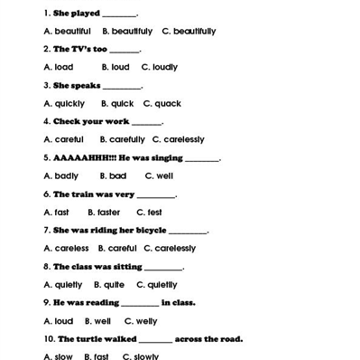
X. SELF-ASSESSMENT:
- The teaching methods are good because:
+ There are facilities and materials for students to study better.
+ The teacher’s preparation is careful.

October 2nd, 2015
ADOPTION OF ENGLISH GROUP Teacher’s signature

Phạm Thị Thu Hiền
Subject: TOEIC 1
Lesson plan: 6 Time allowed: 6 periods Total period taught: 32
Date of teaching: 21/12/2015

UNIT 6: COMPARISONS
I. OBJECTIVES
By the end of the lesson, the students will be able to:
- Develop skills:
+ Listening skill: students listen to statements and choose the best answers for describing the pictures, listen to the short conversations and talks to find out the specific information in order to answer the required questions.
+ Reading skill: students know how to read letter, email, memo, chart…as well as pick up the information so as to answer the questions and choose the best words for blanks.
- Learn and do the exercises about comparisons, preposition “on”, and commonly confused words.
II. TIME
-45 minutes x 6 periods = 270 minutes.
III. METHOD
-Integrated, communicative oriented teaching approach.
IV. TECHNIQUES
-Pair work.
-Group work.
V. TEACHING AIDS
-Text book.
-Black board, chalk.
-Pictures for teaching vocabularies.
-Cassette player, amplifier, microphone.
VI. PROCEDURE
A.Greetings.
B.Checking students’ attendance: 5 minutes
C. Checking the old lesson: Adjectives/ Adverbs

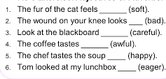

D.New lesson.
Lesson’s contents | Time | Teacher’s activities | Students’ activities
VOCABULARY  A. LISTENING:  Listen and write the letter of the statement that best describes the picture.  B. READING:  Choose the correct words to complete each sentence | 20’  20’ | - T asks Ss to describe what they see in the pictures.  -Teacher (T) teaches new words.  comb (v): using mime    wash(v) using picture  cut (v):using mime    sweep (v): using picture  ski (v): using picture    polish (v): using translation  - T gives instruction.  - T plays the tape without pause.  - T checks the answers and asks Ss a question as follow: “What did you hear from the tape?”  - T gives the correct answers.  - T helps Ss distinguish commonly confused words by giving definition, examples and signals.  Fewer = use with plural nouns  Less = use with uncountable nouns  Object (n): a thing can be seen, touched but is not alive  Subject (n): a thing or a person is being discussed or described  Raise (transitive verb): to lift or move sth to a higher level.  Rise (intransitive verb) + Object: to go or come upward  - T has Ss give examples on their own.  - T has Ss do the exercises.  - T asks Ss to translate each  sentence into Vietnamese.  - T corrects the answers. | -Ss respond to T.  -Ss write down new words.  -Ss listen to the T.  - Ss listen to the tape and answer the questions.  -Ss correct the answers.  Exercise 1:  1. C 2. D 3. B 4.A  Exercise 2:  1. C 2. D  3. B 4. A  -Ss listen to the T and take note.  -Ss do the activity.  - Ss translate and explain why they choose this answer  -Ss check the answers.  Exercise 1:  1. less  2. fewer  Exercise 2:  1. subject  2. object  Exercise 3:  1. raise  2. rise
GRAMMAR FOCUS  COMPARISONS  +Equality  +Comparative  +Superlative | 70’ | - T writes some examples on the board.  1. Mary is as smart as Henry.  2. Mary is smarter than her sister.  3. Mary is the smartest student in her class.  - T asks Ss to draw out the grammar rules.  - T explains the grammar clearly.  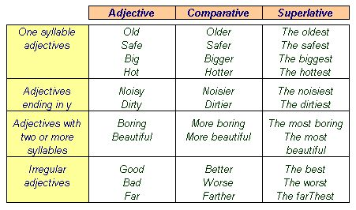  - T asks Ss to give examples for each tense for checking understanding. | - Ss draw out grammar points such as structure, use and signal words.  - Ss listen to T.  - Ss give their own examples.
PREPOSITION:  ON | 20’ | - T gives Ss examples.  1. I will come back on Monday.  2. My vacation started on December 24th.  -T asks Ss to give the use of preposition “ON”  - T reminds Ss some special cases using with preposition “On”: on the beach, on time, on mu street, etc. | - Ss draw out the use of preposition “On”.  - Ss write down in their notebook.  - Ss give some examples on their own.
GRAMMAR  EXERCISES | 40’ | - T asks Ss to repeat the rules of comparisons and write down on the board.  -T preteaches new words.  Expensive (adj): using antonym    Cheetah (n): using picture  Delicious (adj): using explanation  - T gives Ss time to do the exercise.  - T goes around the class to help Ss when they need.  - T calls on Ss to write their answer on the board.  - T asks Ss to explain why they choose that choices.  - T gives feedbacks and corrects the answers. | -Ss respond to T.  -Ss take note new words.  - Ss do the exercise individually or in pairs.  - Ss write the answer on the board.  - Ss explain for T.  - Ss listen to T and correct their own answer.  Answers:  1.earlier  2.much  3.to  4.as  5.much  6.fastest  7.the most  8.to  9.more  10.as
MINI TEST  PART 1:  Picture Description  PART 2:  Questions and Responses  PART 3:  Short Conversations  PART 4:  Short Talks  PART 5:  Incomplete Sentences  PART 6:  Incomplete Texts  PART 7:  Reading Comprehension | 70’  60’  40’  50’ | - T gives Ss 10 minutes to look at 5 pictures in part 1.  - T asks Ss: “What can you see in the picture?”  “What kind of musical instrument is he playing?”  “What are the man and woman doing?”  “What is he doing?”  “How do they look?”  - T introduces some new words if necessary.  - T gives instruction.  - T plays the tape.  - T checks the correct answers.  - T asks Ss to repeat two steps to do part 2:  + Step 1: Listen carefully to the question.  + Step 2: Listen 4 answers and choose the suitable answer for the question which Ss listened to.  - T plays the tape.  - T asks Ss to repeat the questions in the tape.  - T writes the questions on the board.  - T corrects the answers.  - T asks Ss to read the questions and guess the content of conversation.  - T asks Ss to underline the key words in the question.  -T suggests some relating vocabulary.  Cut down (v): using translation  Concentrate (v): using translation.  - T asks Ss: “To do part 3, what information do you need to listen out for?  - T plays the tape without pause.  - T asks Ss to write answer on the board.  - T plays the tape with pause and gives the correct answers.  - T asks Ss to read the questions.  - T asks Ss to underline the important words in the question.  - T asks Ss: “To do part 4, which information do you need to listen out for?  - T introduces some new words if necessary.  Schedule (n); using examples  Wake up (v): using synonym  Huge (adj): using synonym  Purchase (v): using synonym  - T plays the tape without pause.  - T asks Ss to write answer on the board.  - T plays the tape with pause and gives the correct answers.  - T teaches some new words.    Deep (adj): using semantic map  mummy (n): using picture  - T asks Ss to do part 5 in pairs.  - T goes around the class if they need for help.  - T calls on some Ss to write their answers on the board.  - T checks Ss’ understanding and corrects the answers.  - T teaches new words.  Convenient (adj): using semantic map.  Shoe brush (n): using translation  Deadline (adj): using examples  Increase (v): using synonym  Support (v): using explanation  - T asks Ss to repeat the procedure to do the part 6.  -T reminds Ss to look carefully word or pharse before and after the blank.  - T asks Ss to do part 6 in pairs.  - T goes around the class if they need for help.  - T calls on some students to write their answers on the board.  - T checks Ss’ understanding and corrects the answers.  - T explains new words.  Wedding ceremony (n): using translation  Reception (n): using explanation  Europe (n): using examples  -T asks Ss to read and analyze the questions.  - T asks Ss to give the key words in the questions.  - T has Ss to use skimming and scanning skills to do part 7.  - T calls on some Ss to write their answers on the board.  - T asks Ss questions “How can you find out the answer? Which line/ paragraph can you find out the answer?  - T checks Ss’ understanding and corrects the answers. | - Ss look at pictures and answer T’s questions.  -Ss listen and choose the statements.  Answers:  1.A 2.C 3.B 4. C 5. D  -Ss respond to the T.  - Ss listen and apply two steps to complete part 2.  -Ss respond to T.  -Ss check the answers.  Answers:  1. C 2. A 3. B 4. A 5. B  -Ss follow the T.  -Ss respond to T.  - Ss listen to the tape.  - Ss write down the answers on the board.  - Ss listen again and check their answers.  Answers:  1. D 2.B 3. B  4. A 5. C 6. B  - Ss read the questions in pairs.  - Ss underline the important words and answer T’s question.  -Ss take note new words.  -Ss do the exercise.  -Ss write down the answers on the board.  - Ss listen again and check their answers.  Answers:  1. D 2. B 3. B  4. C 5. D 6. A  -Ss take note.  -Ss explain the reason for their choices and write answers on the board.  -Ss check the answers.  Answers:  1. B 2. A 3. C  4. B 5. B 6. D  7. A 8. B 9. A  10. D 11. C 12. C  13. B 14.A 15. B  - Ss do part 6 in pairs.  - Ss write answers on the board.  - Ss explain the reason for their choice and correct the answers.  Answers:  1. C 2. B 3. A  4. C 5. A 6. D  -Ss take note new words.  -Ss listen to the T.  - Ss write answers on the board.  - Ss explain the reason for their choice and correct the answers.  Answers:  1. C 2.B 3. A  4. B 5. C 6. D  7. C 8. A 9. A
STUDENTS TEACH THEMSELVES AT HOME |  | -T asks Ss to pratice at home.  Reading Comprehension  Questions 6 through 9  [Page 140] | - Refer to the directory and email.  - Ss are supposed to review all the learnt lessons in class.  - Ss should reread the reading texts for further understanding.
VII. SUMMARY OF UNIT 6: 5 minutes
- T reminds Ss about:
+ Comparisons.
+ Vocabulary and Grammar Exercises
+ Six parts of the Mini Test.
VIII. HOMEWORK: 5 minutes
- Ss have to do again all the exercises.
- Ss prepare for the new lesson.
IX. SELF-ASSESSMENT:
- The teaching methods are good because:
+ There are facilities and materials for students to study better.
+ The teacher’s preparation is careful.
October 2nd, 2015
ADOPTION OF ENGLISH GROUP Teacher’s signature

Phạm Thị Thu Hiền
Subject: TOEIC 1
Lesson plan: 7 Time allowed: 6 periods Total period taught: 38
Date of teaching: 04/01/2016

UNIT 7: MODIFIERS
I. OBJECTIVES
By the end of the lesson, the students will be able to:
- Develop skills:
+ Listening skill: students listen to statements and choose the best answers for describing the pictures, listen to the short conversations and talks to find out the specific information in order to answer the required questions.
+ Reading skill: students know how to read letter, email, memo, chart…as well as pick up the information so as to answer the questions and choose the best words for blanks.
- Learn and do the exercises about modofiers, preposition “about”, and commonly confused words.
II. TIME
-45 minutes x 6 periods = 270 minutes.
III. METHOD
-Integrated, communicative oriented teaching approach.
IV. TECHNIQUES
-Pair work.
-Group work.
V. TEACHING AIDS
-Text book.
-Black board, chalk.
-Pictures for teaching vocabularies.
-Cassette player, amplifier, microphone.
VI. PROCEDURE
A.Greetings.
B.Checking students’ attendance: 5 minutes
C. Checking the old lesson: Comparisons

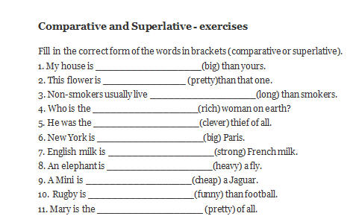

D.New lesson.
Lesson’s contents | Time | Teacher’s activities | Students’ activities
VOCABULARY  A. LISTENING:  Listen and write the letter of the statement that best describes the picture.  B. READING:  Choose the correct words to complete each sentence | 20’  20’ | - T asks Ss to describe what they see in the pictures.  -Teacher (T) teaches new words.  Get up(v): using synonym  Hide(v) using explanation  Wear (v): using example  Rest (v): using example  - T gives instruction.  - T plays the tape without pause.  - T checks the answers and asks Ss a question as follow: “What did you hear from the tape?”  - T gives the correct answers.  - T helps Ss distinguish commonly confused words by giving definition, examples and signals.  Either = using in negative sentences. It comes at the end of a clause.  Too = using in positive sentences to add an agreement thought. It usually comes at the end of aclause.  Look (v)= refer to sight, to an impression getting by seeing  Seem (v)=refer to an impression coming from an opinion  Hear = means that sounds come into your ears whether you want it or not.  Listen = means that you consciously pay attention to what you hear, that is you want to hear something.  - T has Ss give examples on their own.  - T has Ss do the exercises.  - T asks Ss to translate each  sentence into Vietnamese.  - T corrects the answers. | -Ss respond to T.  -Ss write down new words.  -Ss listen to the T.  - Ss listen to the tape and answer the questions.  -Ss correct the answers.  Exercise 1:  1. B 2. A 3. D 4.C  Exercise 2:  1. D 2. C  3. B 4. A  -Ss listen to the T and take note.  -Ss do the activity.  - Ss translate and explain why they choose this answer  -Ss check the answers.  Exercise 1:  1. Too  2. either  Exercise 2:  1. looks  2. seems  Exercise 3:  1. hear  2. listen
GRAMMAR FOCUS  MODIFIERS | 70’ | - T writes some examples on the board and draw out the grammar rules.  - T explains the grammar clearly.  1.Verb +Adjective  Ex: The food tastes aweful.  2.Many/ Few + C. Nouns  Ex: Many students pass the final exam.  3. Much/ Little + U. Noun  Ex: I have not much money.  4. Each/ Every + S. Noun  Ex: Each classroom has air conditioning.  Each of + Plural Noun  Ex: Each of the members did her best.  5.SOME: used in affirmative sentences and suggestions  Ex:I bought some books.  6.ANY: used in negative and interrogative sentences  Ex: I didn’t have any money.  7. SUCH + a/an + adj + N  SO + a/an + adj + N  SO + Adj/ adv  Ex: He is such a kind person.  He is so strong a person.  8.ENOUGH + Noun  Ex: I have enough money to buy a phone.  Adjective + ENOUGH  Ex: He is old enough to drink beer.  9. ALMOST + Adj  Ex: Most people who live there go to the park every week.  MOST + Plural Noun  Ex: I go to the park everyday.  10. thing/ - one/ -body +adj  Ex:She would like to eat something warm.  - T asks Ss to give examples for each tense for checking understanding. | - Ss draw out grammar points such as structure, use and signal words.  - Ss listen to T.  - Ss give their own examples.
PREPOSITION:  ABOUT | 20’ | - T gives Ss examples.  1. The book is about Korean history.  2. I bought this book about 5$.  -T asks Ss to give the use of preposition “about”  - T reminds Ss some special cases using with preposition “about”: about 6p.m, about 10$, about the park, etc. | - Ss draw out the use of preposition “about”.  - Ss write down in their notebook.  - Ss give some examples on their own.
GRAMMAR  EXERCISES | 40’ | - T asks Ss to repeat the rules of comparisons and write down on the board.  -T preteaches new words.  - T gives Ss time to do the exercise.  - T goes around the class to help Ss when they need.  - T calls on Ss to write their answer on the board.  - T asks Ss to explain why they choose that choices.  - T gives feedbacks and corrects the answers. | -Ss respond to T.  -Ss take note new words.  - Ss do the exercise individually or in pairs.  - Ss write the answer on the board.  - Ss explain for T.  - Ss listen to T and correct their own answer.  Answers:  1.terrible  2.really  3.a number of  4.student  5.any  6.very  7.enough money  8.something warm  9.most  10.such
MINI TEST  PART 1:  Picture Description  PART 2:  Questions and Responses  PART 3:  Short Conversations  PART 4:  Short Talks  PART 5:  Incomplete Sentences  PART 6:  Incomplete Texts  PART 7:  Reading Comprehension | 70’  60’  40’  50’ | - T gives Ss 10 minutes to look at 5 pictures in part 1.  - T asks Ss: “What can you see in the picture?”  “What does he do?”  “What is the man holding?”  “Where are they?”  “What is he catching?”  “What are they doing?”  - T introduces some new words if necessary.  - T gives instruction.  - T plays the tape.  - T checks the correct answers.  - T asks Ss to repeat two steps to do part 2:  + Step 1: Listen carefully to the question.  + Step 2: Listen 4 answers and choose the suitable answer for the question which Ss listened to.  - T plays the tape.  - T asks Ss to repeat the questions in the tape.  - T writes the questions on the board.  - T corrects the answers.  - T asks Ss to read the questions and guess the content of conversation.  - T asks Ss to underline the key words in the question.  -T suggests some relating vocabulary.  Envelop (n); using picture.    Discount (n): using example  Local (adj): using translation  - T asks Ss: “To do part 3, what information do you need to listen out for?  - T plays the tape without pause.  - T asks Ss to write answer on the board.  - T plays the tape with pause and gives the correct answers.  - T asks Ss to read the questions.  - T asks Ss to underline the important words in the question.  - T asks Ss: “To do part 4, which information do you need to listen out for?  - T introduces some new words if necessary.  Relax (v): using explantion  Energy (n): using explanation  Vacation (n): using example  - T plays the tape without pause.  - T asks Ss to write answer on the board.  - T plays the tape with pause and gives the correct answers.  - T teaches some new words.  Score (v): using example  Helicopter (n): using picture    - T asks Ss to do part 5 in pairs.  - T goes around the class if they need for help.  - T calls on some Ss to write their answers on the board.  - T checks Ss’ understanding and corrects the answers.  - T teaches new words.  Trash can (n): using explanation  Inconvenient (adj): using antonym  Complain (v): using translation  Exchange (v): using example  - T asks Ss to repeat the procedure to do the part 6.  -T reminds Ss to look carefully word or pharse before and after the blank.  - T asks Ss to do part 6 in pairs.  - T goes around the class if they need for help.  - T calls on some students to write their answers on the board.  - T checks Ss’ understanding and corrects the answers.  - T explains new words.  Operate (v): using semantic map  Regular (adj): using explanation  Soft drinks (n):using example  Ketchup (n): using translation  -T asks Ss to read and analyze the questions.  - T asks Ss to give the key words in the questions.  - T has Ss to use skimming and scanning skills to do part 7.  - T calls on some Ss to write their answers on the board.  - T asks Ss questions “How can you find out the answer? Which line/ paragraph can you find out the answer?  - T checks Ss’ understanding and corrects the answers. | - Ss look at pictures and answer T’s questions.  -Ss listen and choose the statements.  Answers:  1.C 2.B 3.C 4. A 5. A  -Ss respond to the T.  - Ss listen and apply two steps to complete part 2.  -Ss respond to T.  -Ss check the answers.  Answers:  1. B 2. A 3. A 4. A 5. A  -Ss follow the T.  -Ss take note new words.  -Ss respond to T.  - Ss listen to the tape.  - Ss write down the answers on the board.  - Ss listen again and check their answers.  Answers:  1. A 2.C 3. BA  4. C 5. D 6. D  - Ss read the questions in pairs.  - Ss underline the important words and answer T’s question.  -Ss take note new words.  -Ss do the exercise.  -Ss write down the answers on the board.  - Ss listen again and check their answers.  Answers:  1. C 2. A 3.D  4. A 5. A 6. C  -Ss take note.  -Ss explain the reason for their choices and write answers on the board.  -Ss check the answers.  Answers:  1. D 2. A 3. C  4. C 5. C 6. A  7. B 8. B 9. A  10. D 11. C 12. D  13. A 14.B 15. C  - Ss do part 6 in pairs.  - Ss write answers on the board.  - Ss explain the reason for their choice and correct the answers.  Answers:  1. D 2. A 3. A  4. C 5. B 6. D  -Ss take note new words.  -Ss listen to the T.  - Ss write answers on the board.  - Ss explain the reason for their choice and correct the answers.  Answers:  1. B 2.D 3. C  4. D 5. D 6. C  7. B 8. D 9. B
STUDENTS TEACH THEMSELVES AT HOME |  | -T asks Ss to pratice at home.  Reading Comprehension  Questions 6 through 9  [Page 168] | - Refer to the directory and email.  - Ss are supposed to review all the learnt lessons in class.  - Ss should reread the reading texts for further understanding.
VII. SUMMARY OF UNIT 7: 5 minutes
- T reminds Ss about:
+ Modifiers.
+ Vocabulary and Grammar Exercises
+ Six parts of the Mini Test.
VIII. HOMEWORK: 5 minutes
- Ss have to do again all the exercises.
- Ss prepare for the new lesson.
IX. SELF-ASSESSMENT:
- The teaching methods are good because:
+ There are facilities and materials for students to study better.
+ The teacher’s preparation is careful.
October 2nd, 2015
ADOPTION OF ENGLISH GROUP Teacher’s signature

Phạm Thị Thu Hiền

